Intern Name :- Mopidevi Viswanath

Intern ID :3109

Assigned Task

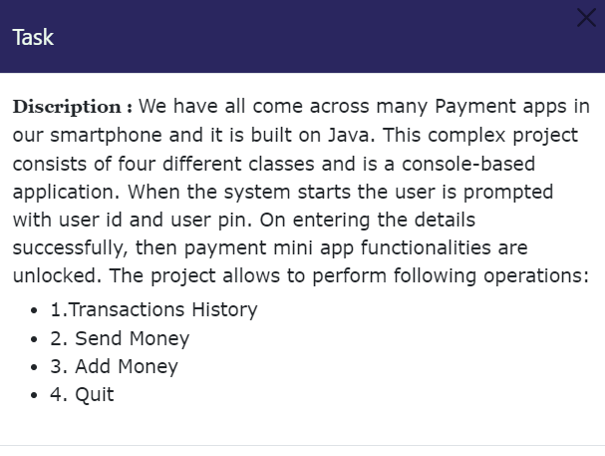

It is a basic console-based Payment Application built using java . The application prompts the user for their user id and pin upon successful login , allows the user id and pin upon start up , and upon successful login , allows the user to access Various functionalities such as viewing transaction history, sending money, adding money, and quitting application . it seems to be a simple project with four main classes and basic functionality

Java Code :-

import java.util.Scanner;

public class Login {

public static void main(String[] args) {

Scanner scanner = new Scanner(System.in);

System.out.print("Enter user id: ");

String userId = scanner.nextLine();

System.out.print("Enter user pin: ");

String userPin = scanner.nextLine();

// Validate user id and pin here

if (validateCredentials(userId, userPin)) {

displayMainMenu();

} else {

System.out.println("Invalid user id or pin. Please try again.");

}

}

private static boolean validateCredentials(String userId, String userPin) {

// Validation logic here

return true;

}

private static void displayMainMenu() {

System.out.println("1. Transactions History");

System.out.println("2. Send Money");

System.out.println("3. Add Money");

System.out.println("4. Quit");

}

}

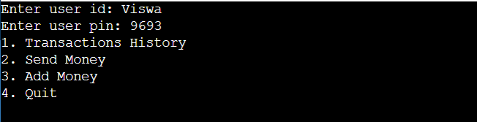

This Class prompts the user for their user id and pin then calls the Validate Credentials method to check the entered credentials . if the credentials are valid , it calls the display Main Menu method to show the available options to the user .

For the transactions history, sending money, adding money and quit functionality , you would need to create separate classes for each functionality and call then when the user selects the Corresponding option from main menu .

Its important to note that this is a simple implementation that does not include any security measures such as encryption or secure storage of user credentials.in a real world implementation, these measures such as encryption or secure storage of user credentials . in a real world implementation, these measures would be necessary to protect sensitive user data.